

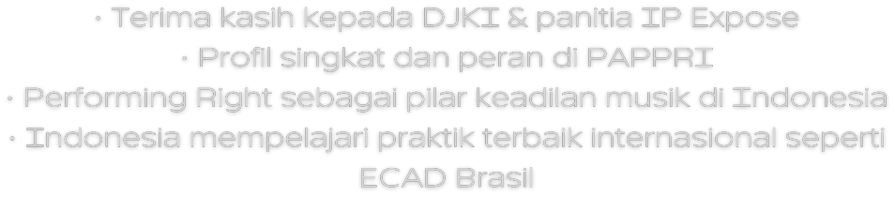

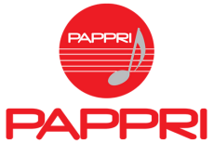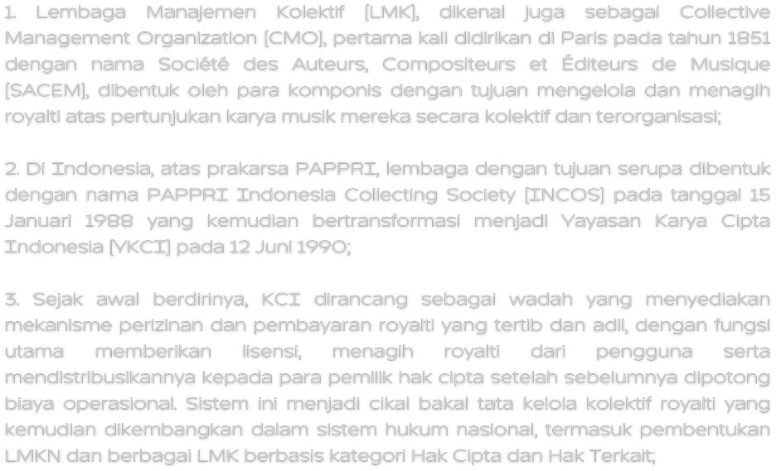

Collecting Society

PHONOGRAPHIC
PERFORMENCE
BRODCAST PUBLIC PERFORMANCE JUKEBOX
LIMITED ( PPL)*
PERFORMING
RIGHT ROYALTY
SONG WRITTER
PRODUCER
MUSIC
PUBLISHING COMPANY
RECORDING
COMPANY
INTERMEDIARIES
ARTIST MANAGEMENT
PERFORMER OR
ARTIST
